# 1. Open cache window

From menu bar, select Tool->Assets Cache

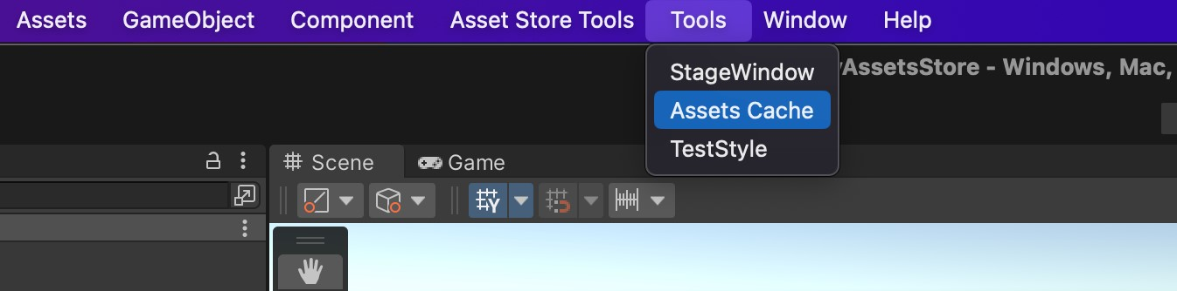

A window will appear like this. Move it to any position you want.

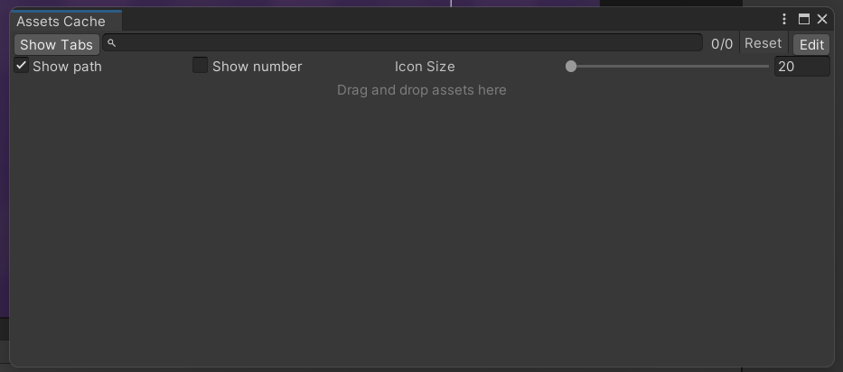

# 2. Cache asset

Any assets you often visit, drag and drop it into the Assets Cache window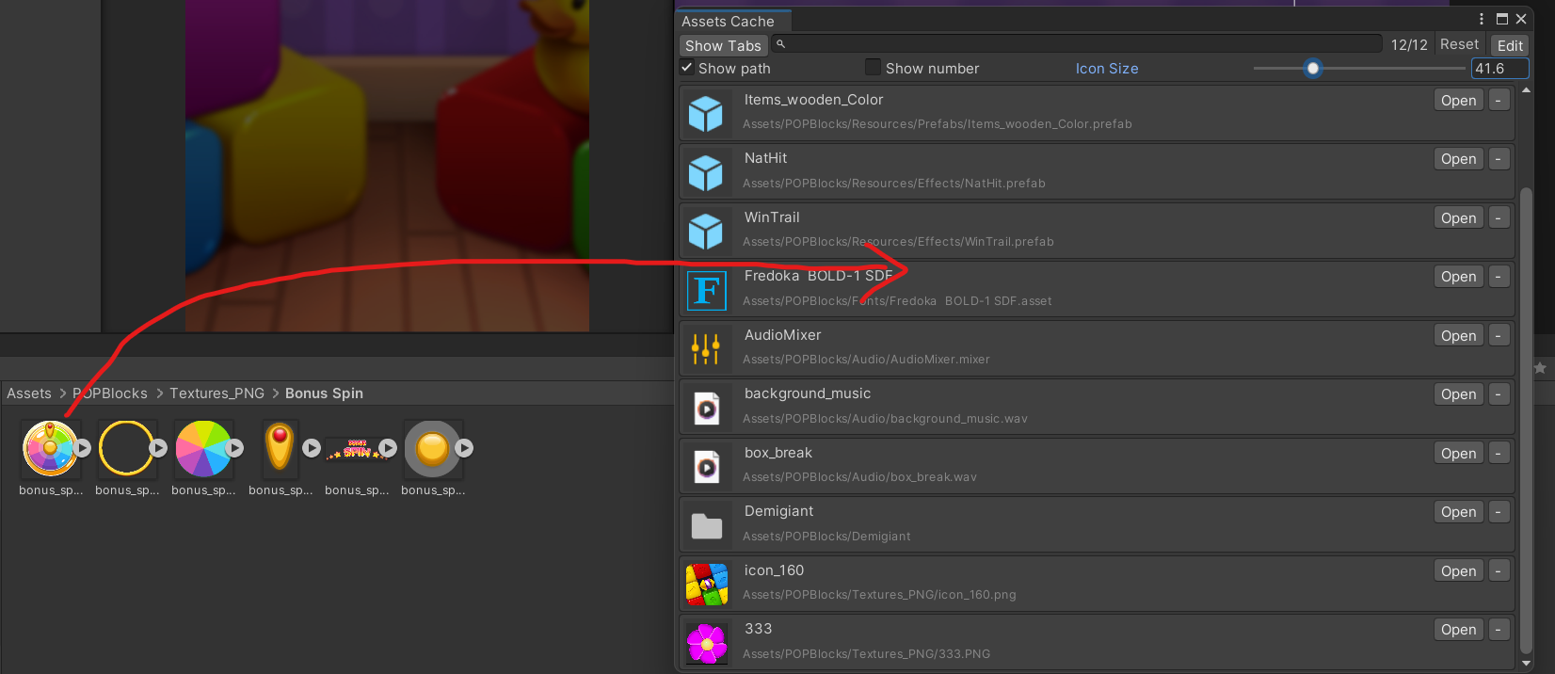

Click on the label to ping it.

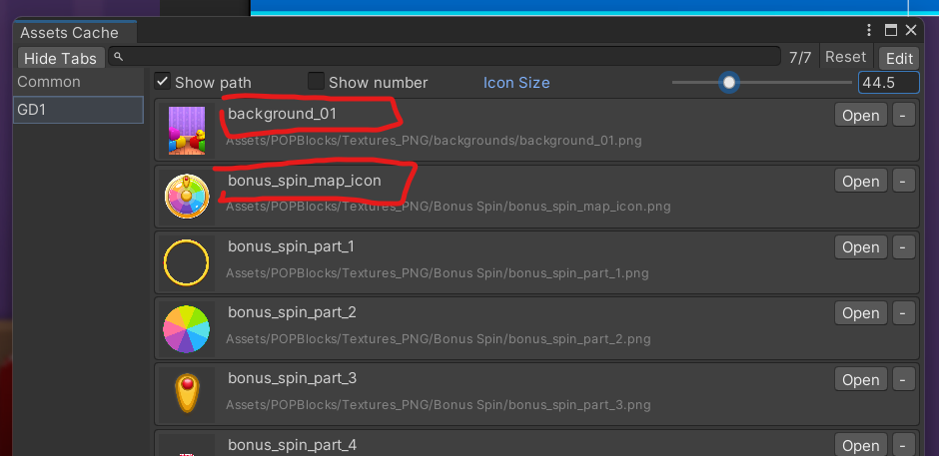

Grab the icon and drag it, you can drop it in several places like Scene view, Hierarchy, Inspector

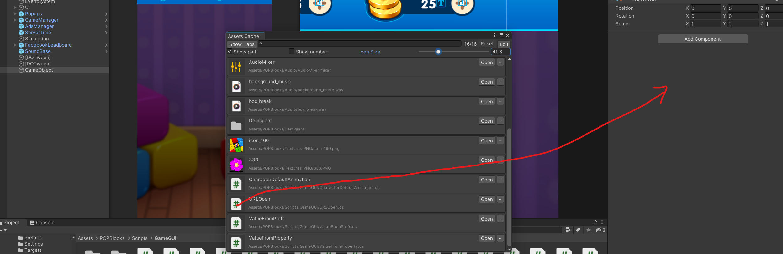

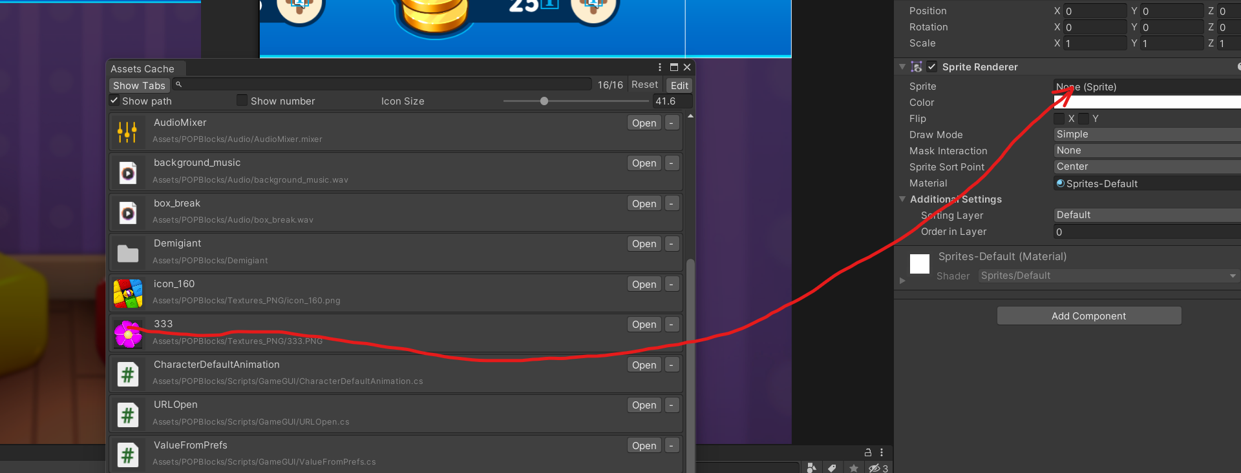

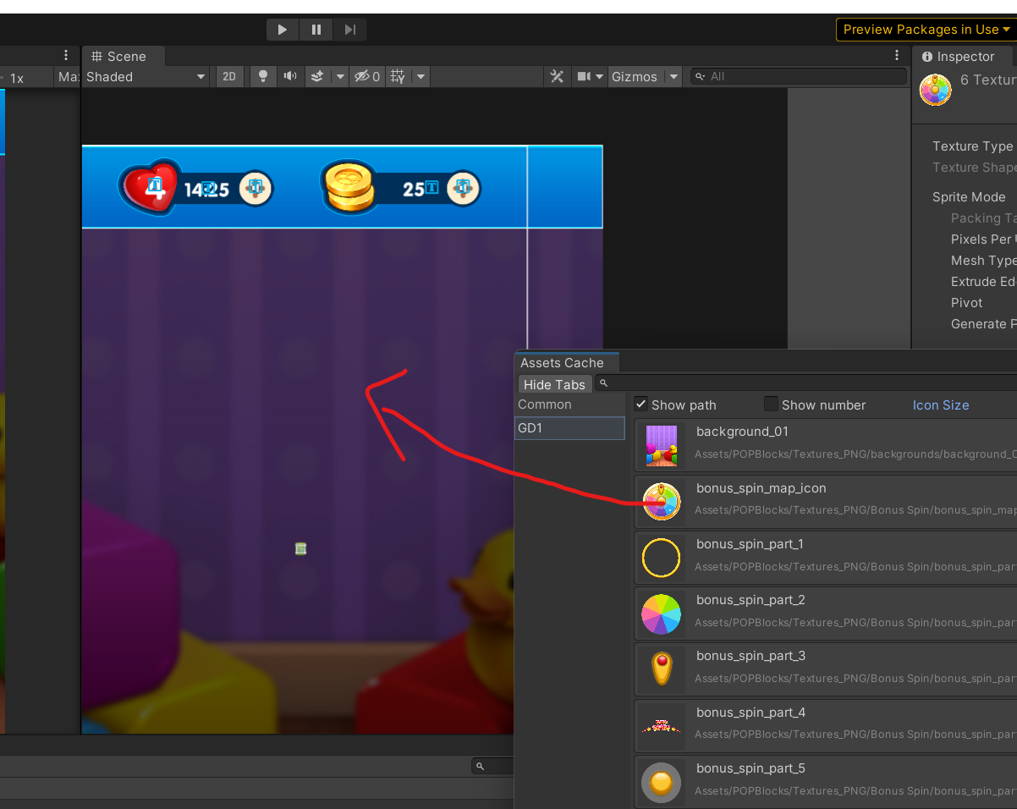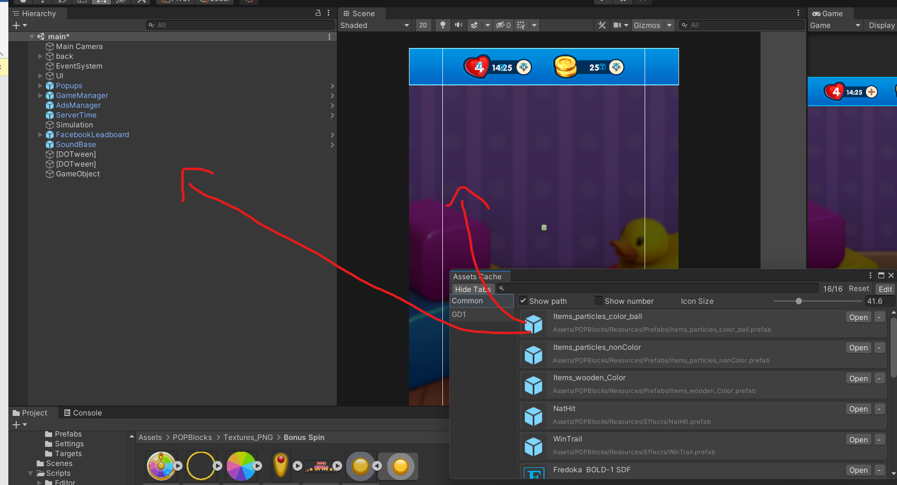

Enter to search box to filter some result you need

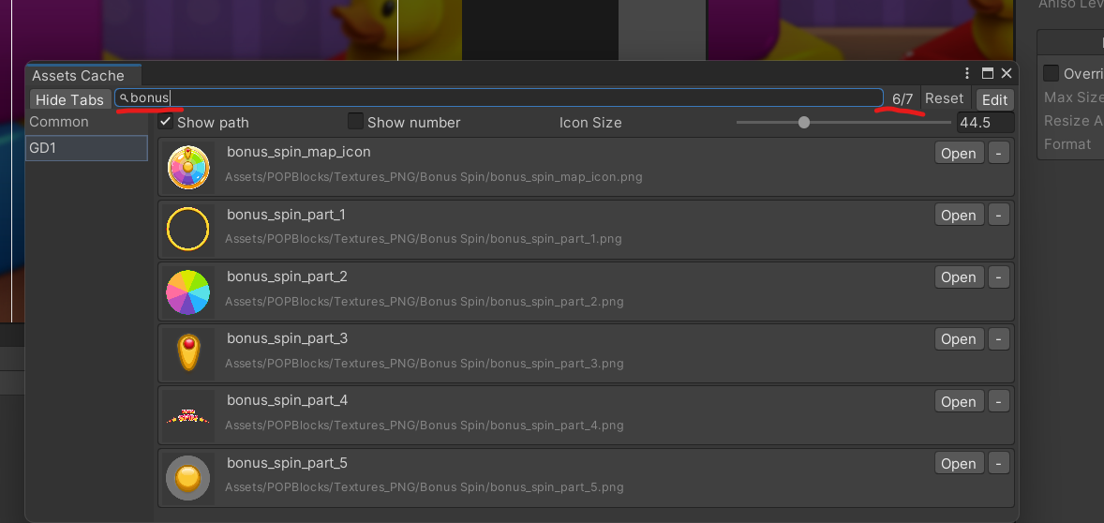

# 5. Edit

Click edit button to open edit mode

You can drag to sort cache list

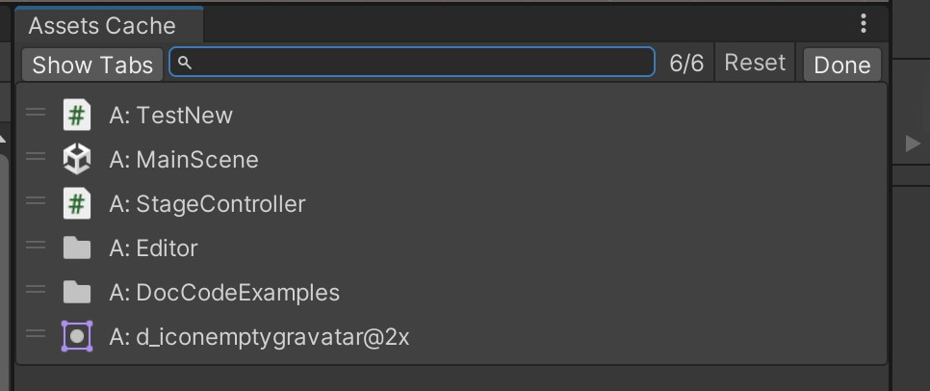

Click to Show tabs button to add, rename, or delete tabs (cache group)

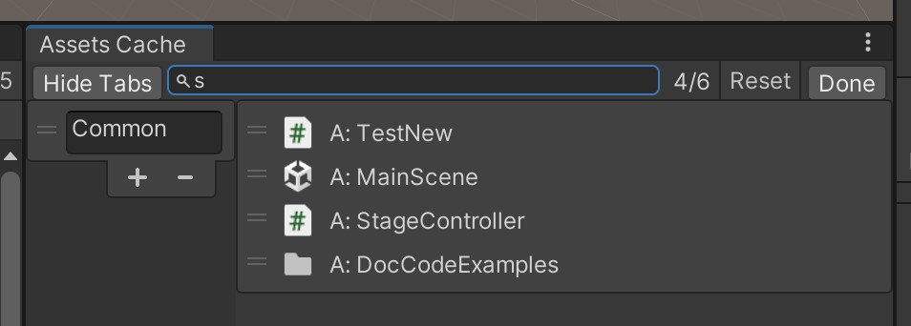

# 6.Tips

Hold control + click to quick ping